Step1: Open Workstation pro click on Create a new Virtual machine.

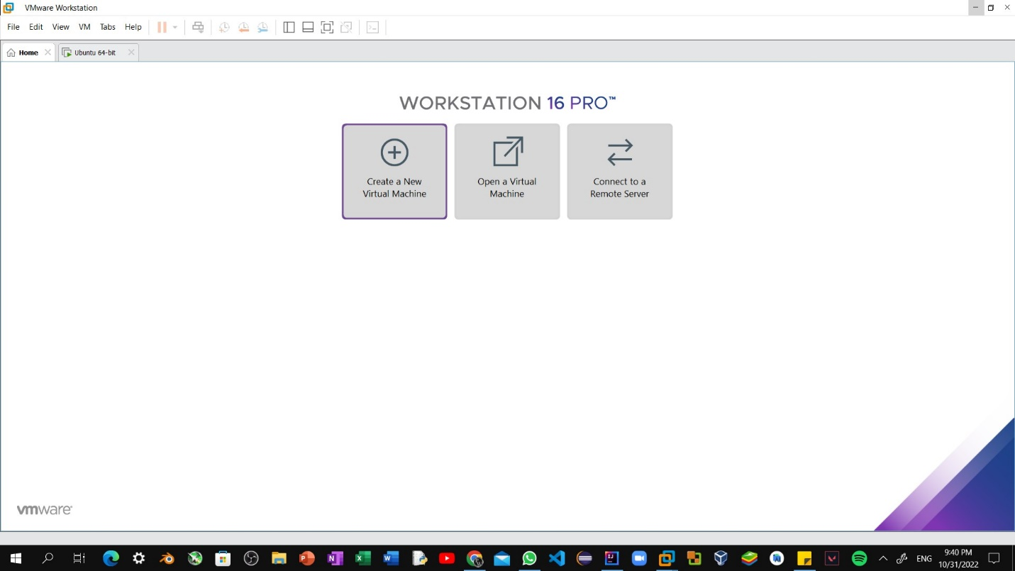

Step2: Select the downloaded disc image file of esxi from your computer. 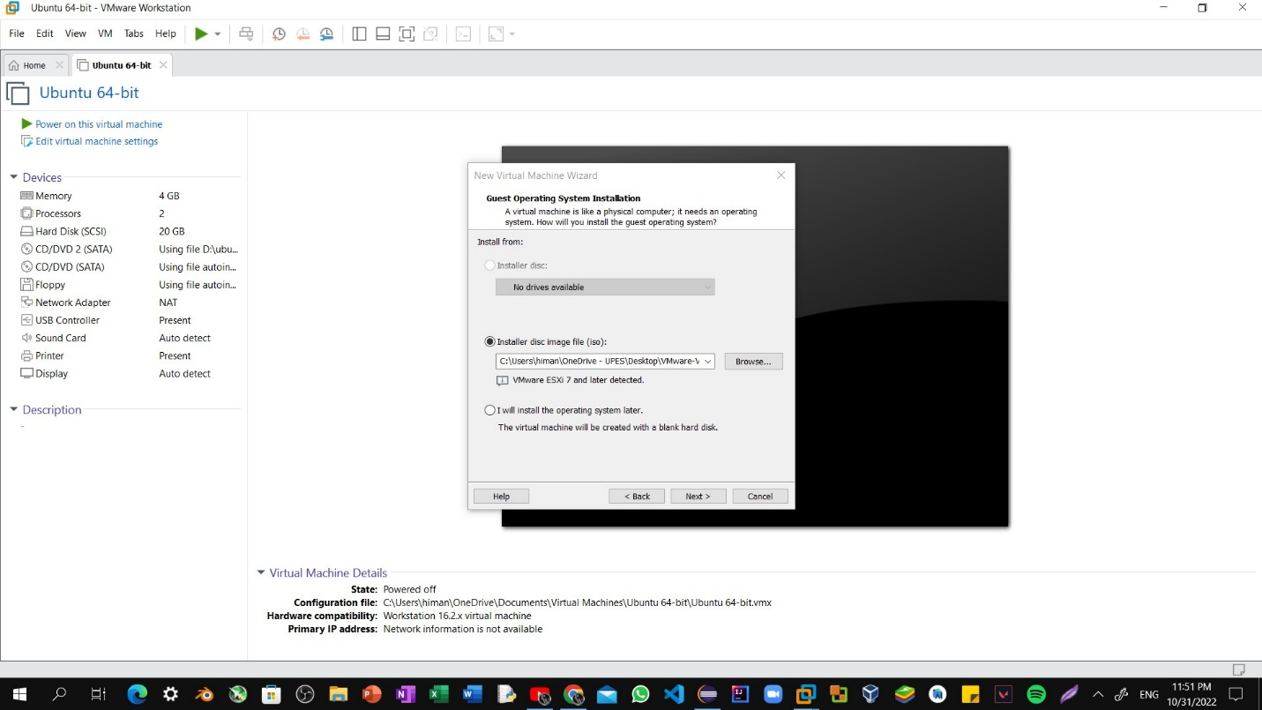

Step3: Selecting iso file of ESxi.

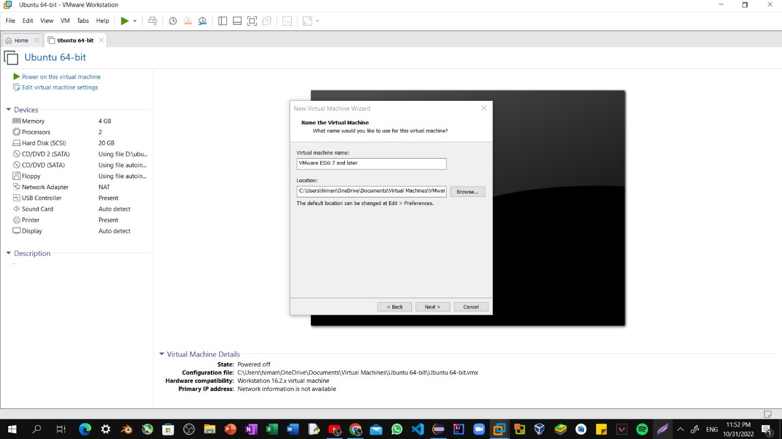

Step4: The installation has been started.

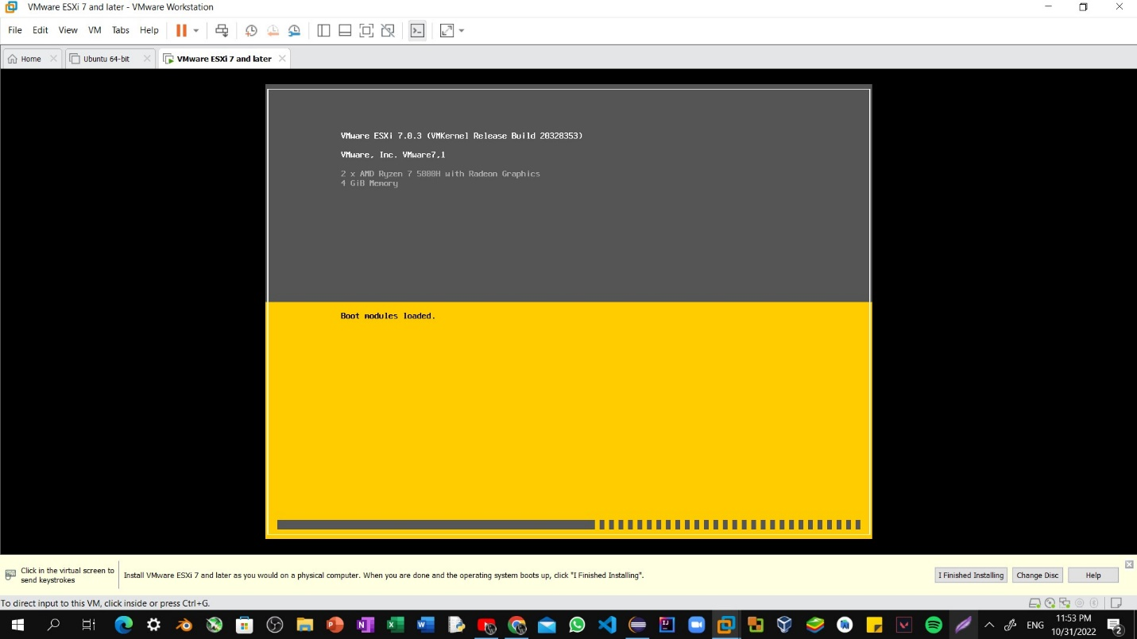

Step5: Click on continue option.

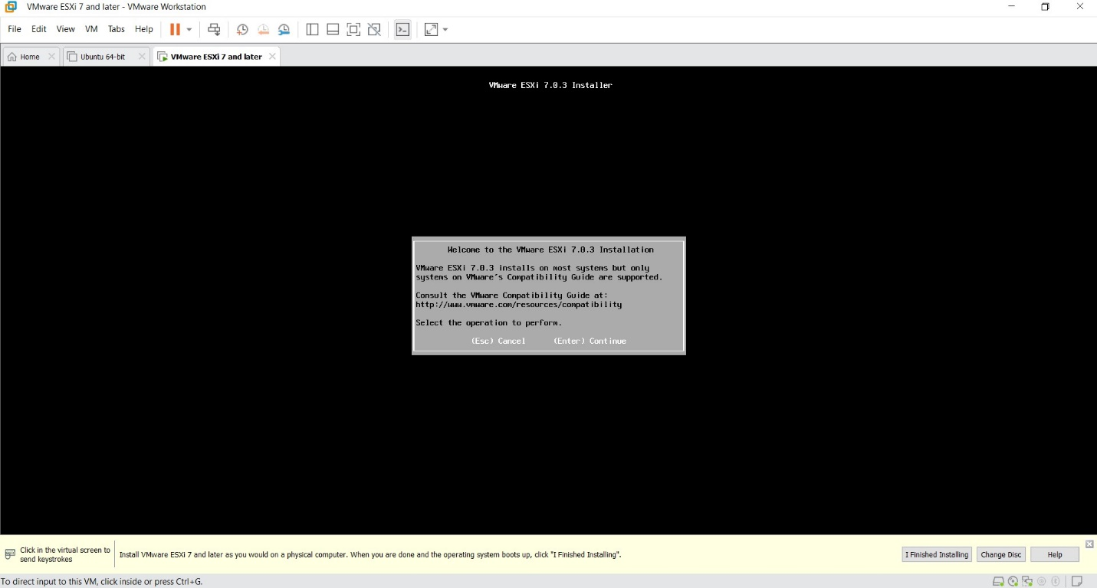

Step6: After doing further settings the installation will start begin. 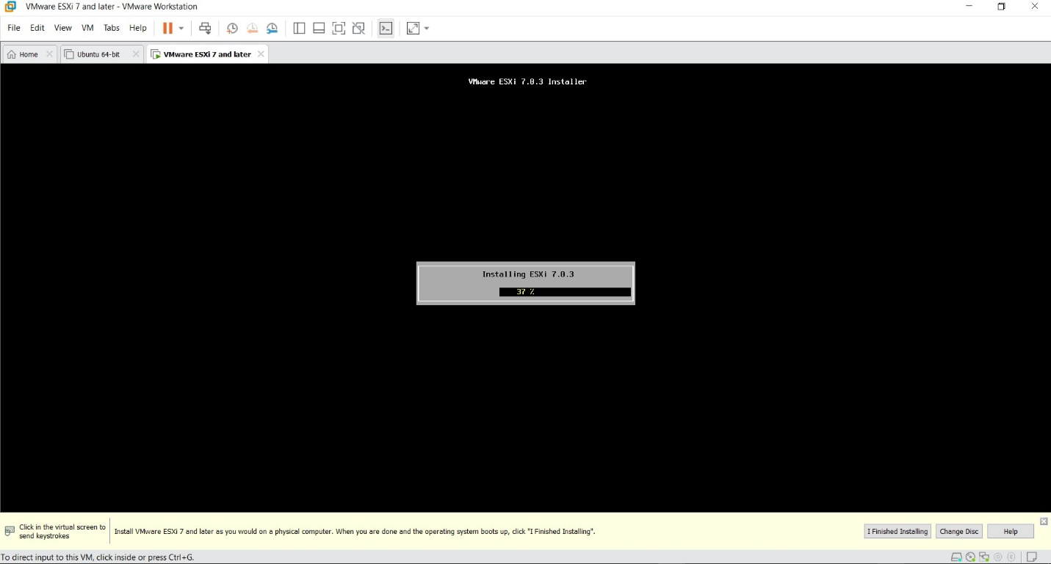

Step7: After installing esxi on workstation pro you will find your own site which you have type on google.

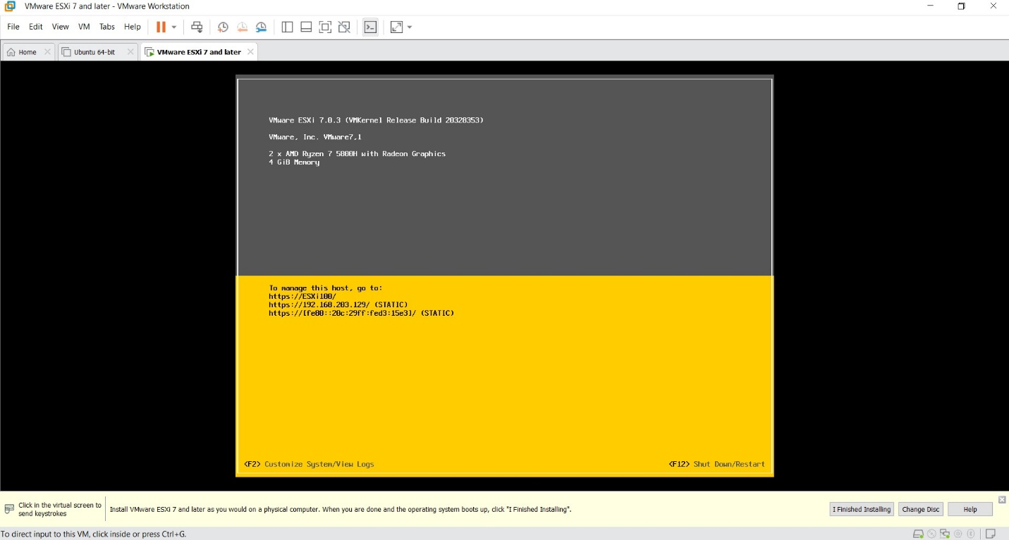

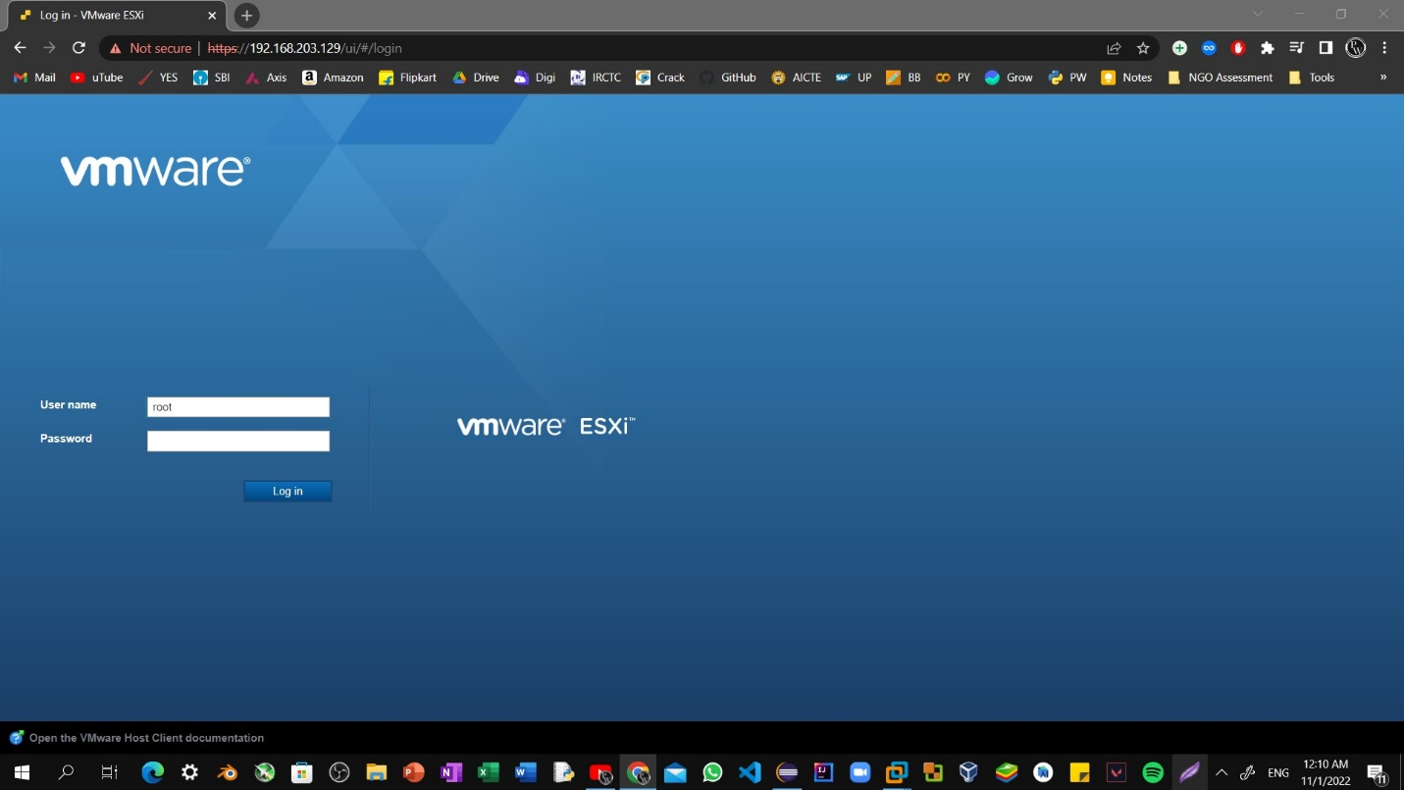Step8: Open ip address on any web browser.

Step9: Right click on host click on to create new virtual machine.

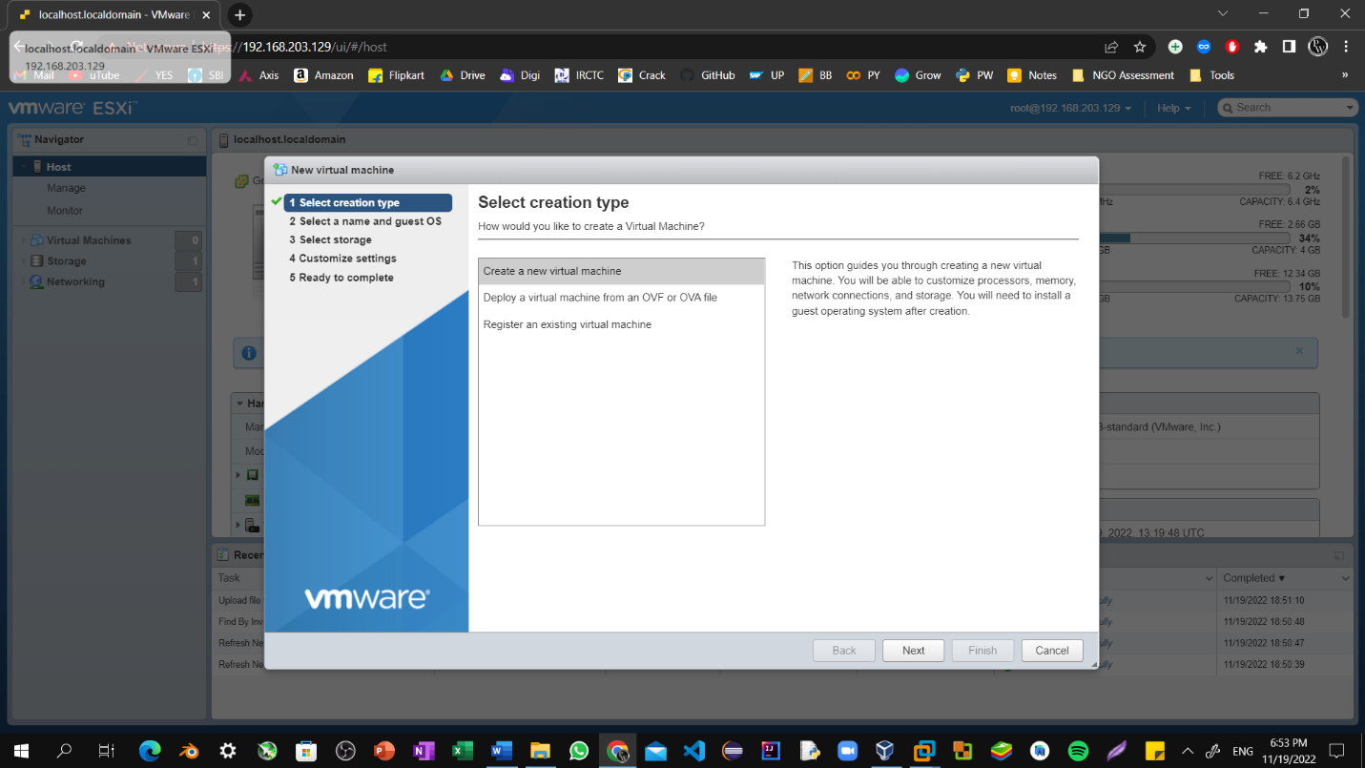

Step10: Choose the virtual machine name, its guest os and guest os version.

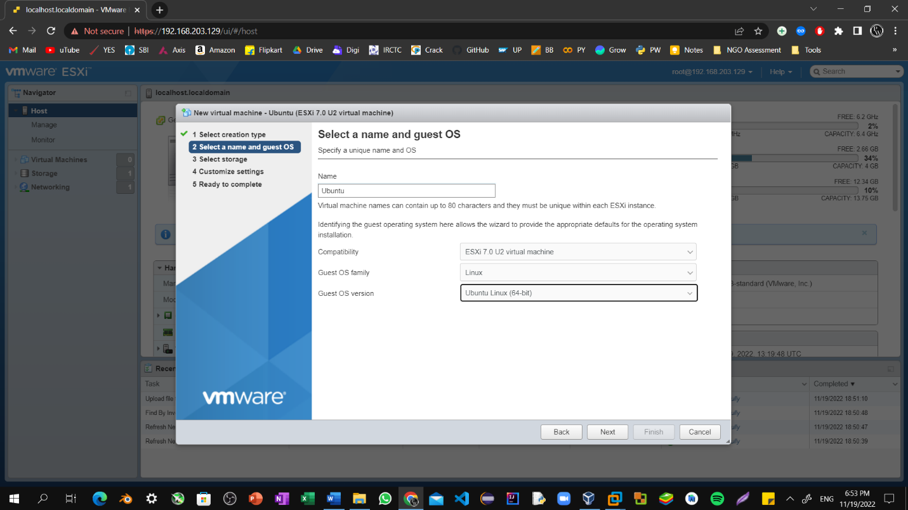

Step11: Proceed Further by clicking on next.

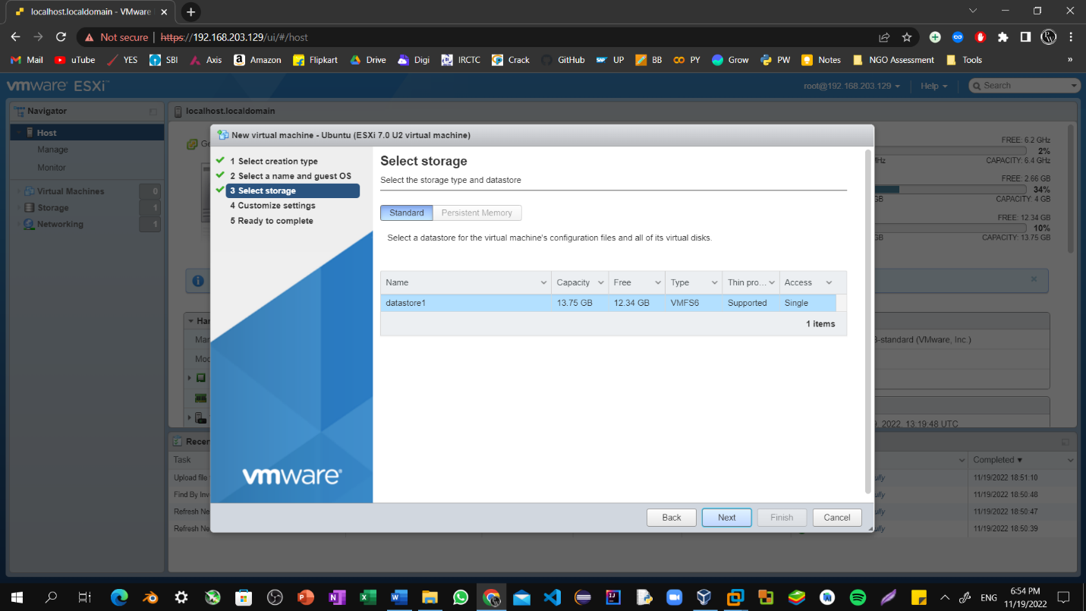

Step12: Upload VM file of Ubuntu by clicking over upload button.

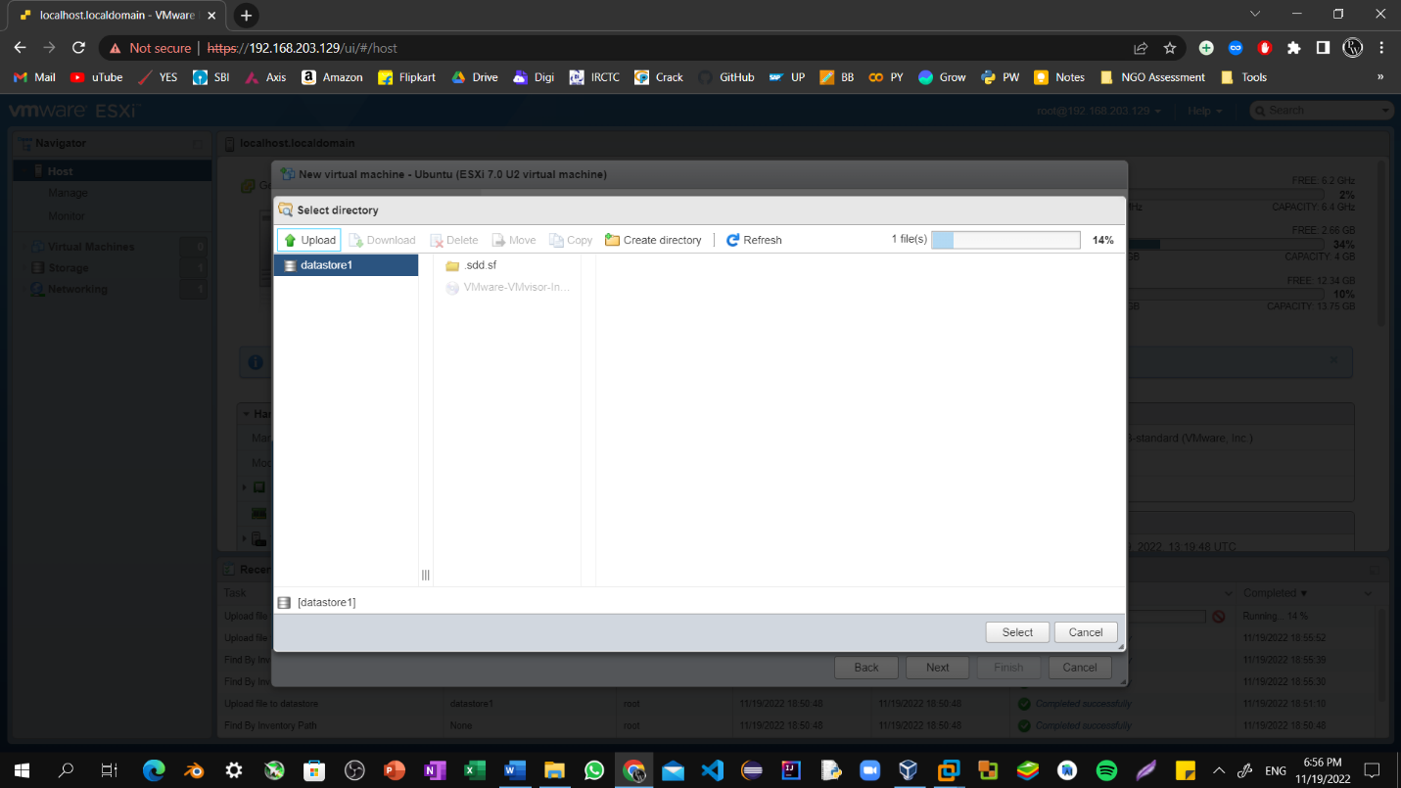

Step12: Customize the required cpu, memory and select the iso file of your virtual machine.

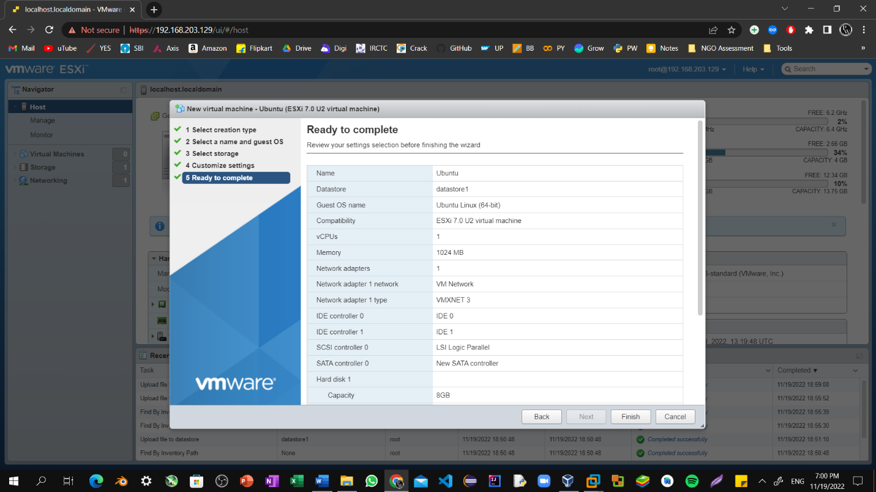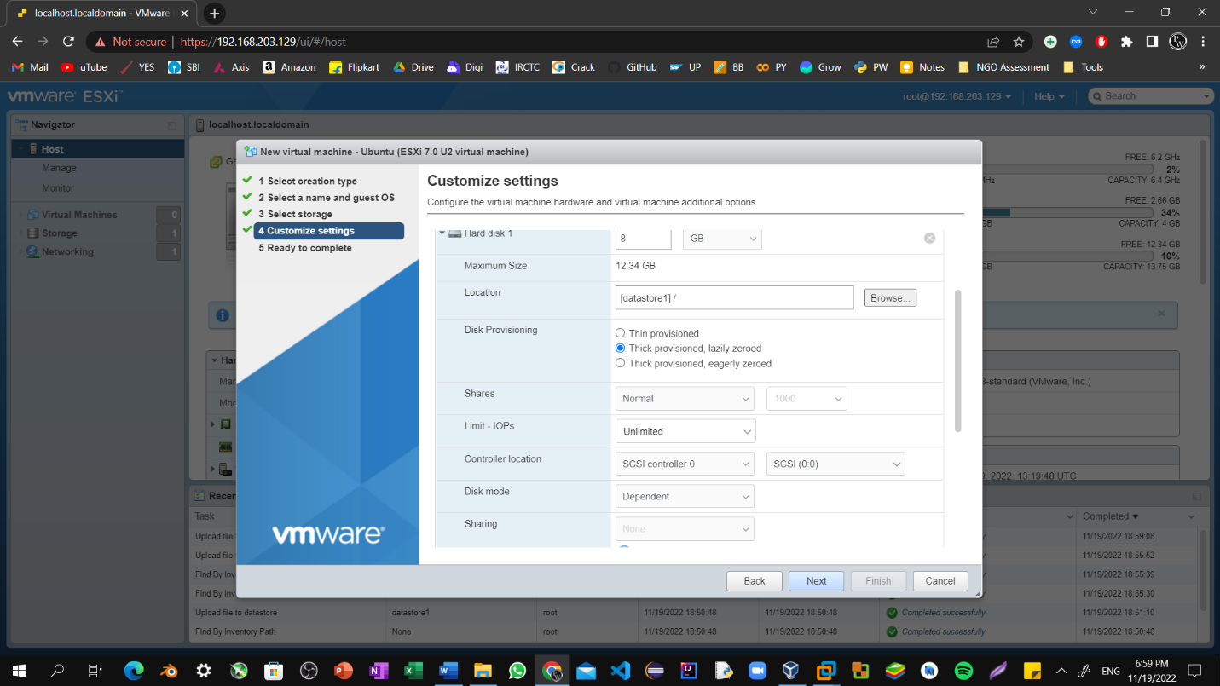  
Step13: Click on Finish and to proceed further.

Step14: Now go to virtual machine tab where you find the virtual machine which is created by you.

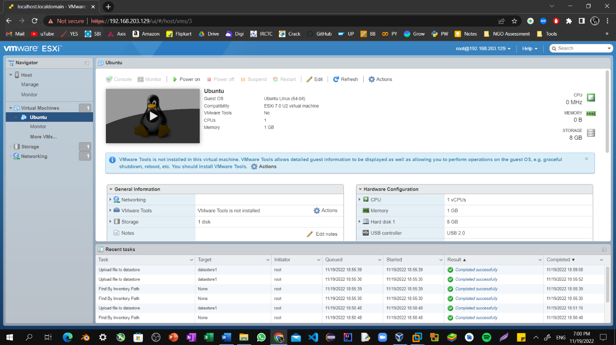

Step15: Click on virtual machine’s image and it will start installing.

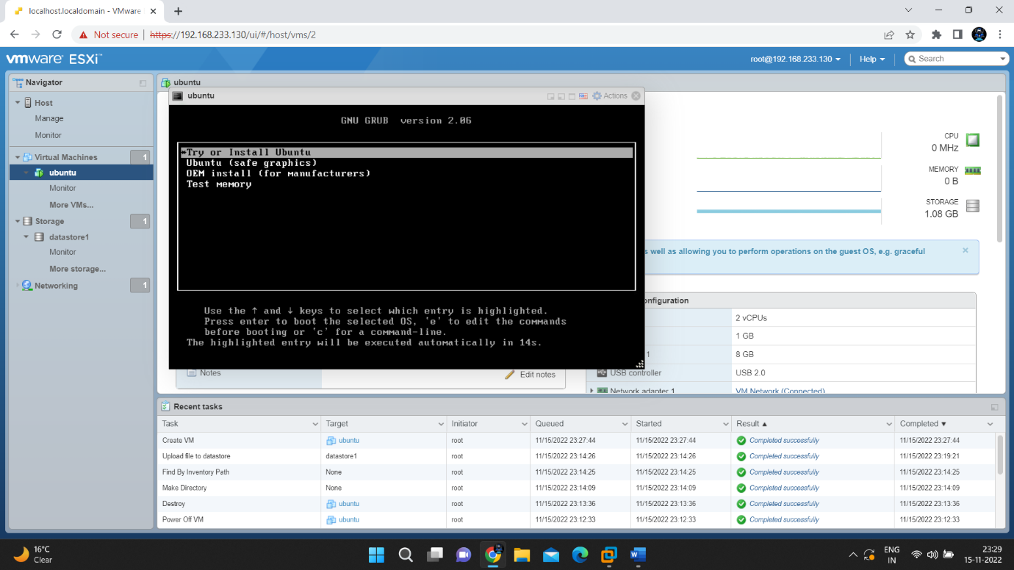

Step16: Now your virtual machine is installing on esxi.

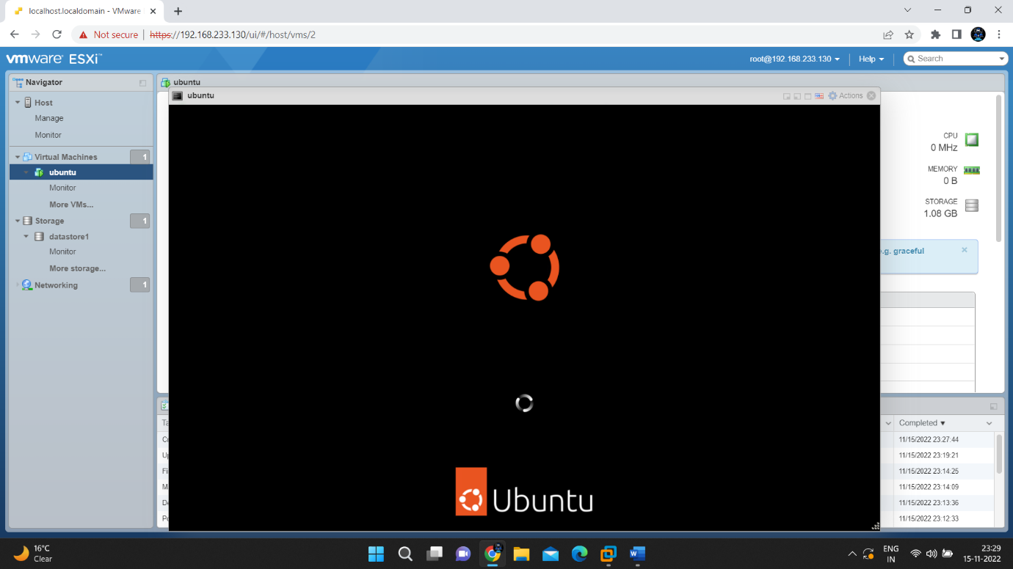

Step17: Now the virtual machine had been successfully installed on esxi.

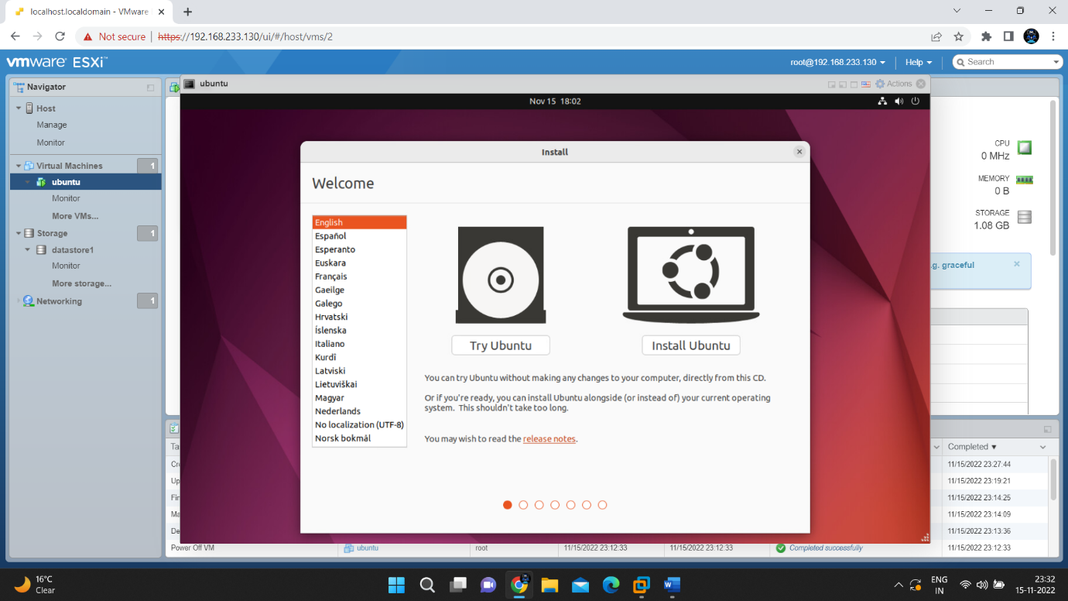

Step18: You can select language to stat further your virtual machine.

